**Facial expression analysis results**

* The images selected for analysis are taken from online sources and images collected from MSRMH (Proparatory database).
* Open source database such as NPAD, ICOPE database and internet sources.
* Different activities of the baby are recorded which includes cries and sleep of the baby. Videos are recorded at a frame rate of 30 fps.
* For facial expression analysis, videos are first converted into frames. 20% of frames are taken for anlaysis
* These frames are then selected based on following criteria
* (a) Selecting Random frames -20% of frames are taken for analysis by considering first, mid and last frame.

(b) Selecting frames based on SSIM (Structural Similarity Index) values by varying threshold values.

(c) Selection based on correlation and PSNR values.

* For motion estimation entire video is considered for analysis.

**Table 1 Details of recorded data**

|  |  |  |  |  |  |  |
| --- | --- | --- | --- | --- | --- | --- |
| **PATIENT ID** | **Gender** | **Gestation Week** | **Duration of recording** | **Frame Rate** | **Camera used for recording** | **Diagnosis** |
| PTV001 | M | 34 weeks | 00.04.09 | 30fps | Wifi camera | PT |
| PTV017 | M | 37 weeks | 00.01.10 | 30fps | Mobile | PT/AGA/M |
| PTV018 | M | 28 weeks | 00.03.39 | 30fps | Mobile | PT/AGA/RDS |
| PTV016 | M | 32 weeks | 00.21.55 | 30fps | Wifi camera | Preterm / Perinatal Depression |
| PTV015 | M | 32 weeks | 00.03.00 | 30fps | Mobile | Late PT/AGA |
| FTV003 | M | 40 weeks | 00.03.00 | 30fps | Mobile | Term/SGA/Male/Congenital Hydrocephalus |
| FTV001 | M | 37 Weeks | 00.21.96 | 30fps | Wifi camera | Term /AGA/ MAS |
| FTV002 | M | 40 weeks | 00.21.55 | 30fps | Wifi camera | Term /AGA/ MSAF |

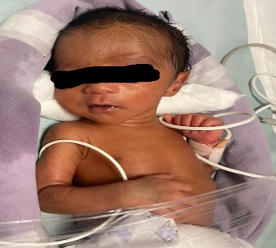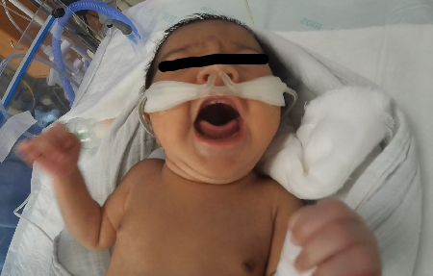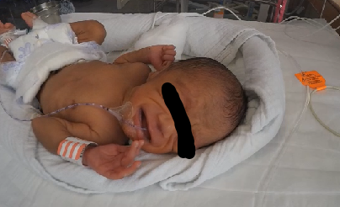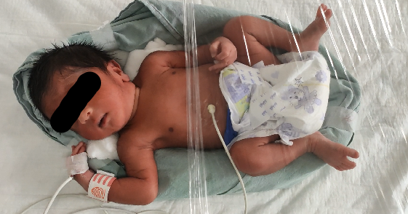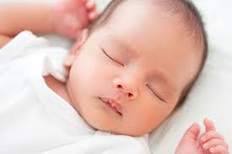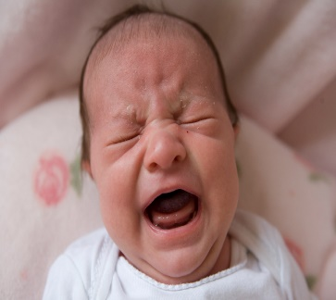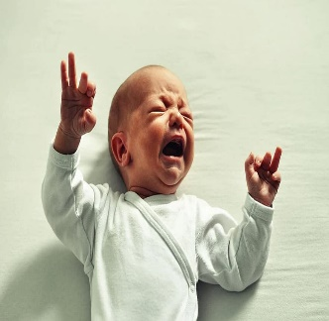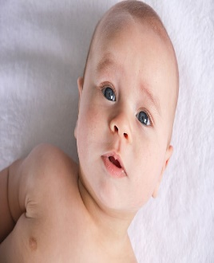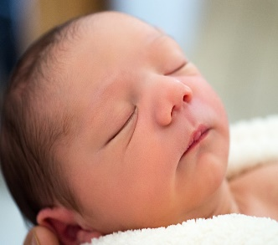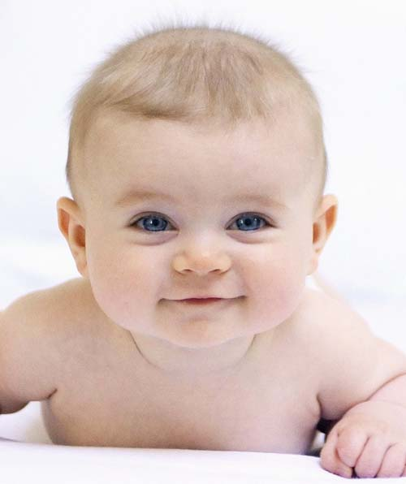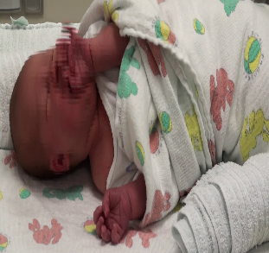 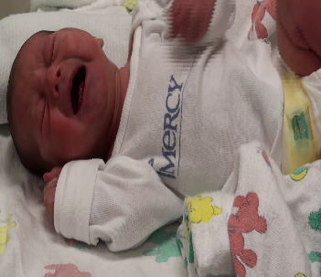 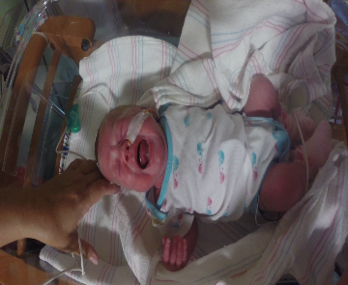 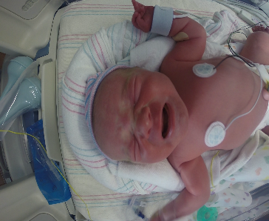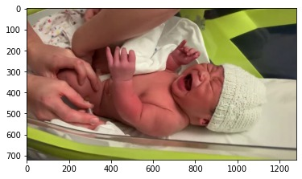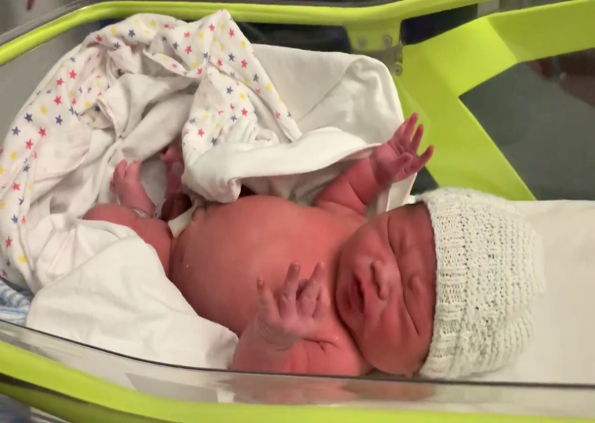

**Method 1**

**Detecting facial features which includes face detection, non-skin region extraction and morphological processing**

* Read the input video frame image
* Convert the image into grayscale image.
* Enhance the input image with median, wiener and Gaussian filters.
* Find the best filter based on PSNR, RMSE values.
* Apply viola-jones algorithm to detect the face region.
* Use bounding box method and crop the face region.
* Use threshold value to extract non skin regions.
* Apply morphological operations to extract continuous boundaries of non-skin region.
* Mask the boundary from the original image.
* Extract the mouth region.
* Area is calculated from extracted mouth region.
* Recognize facial emotions based on the value of area.

**Outputs**

   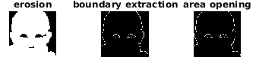

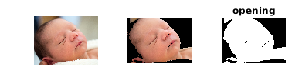 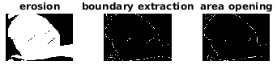

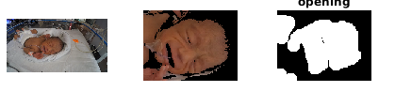 

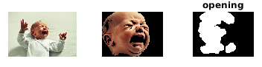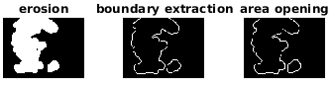

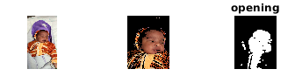 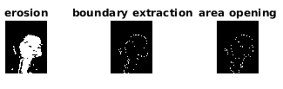

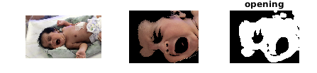 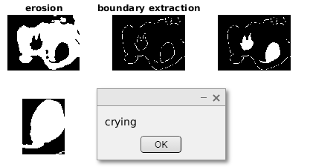

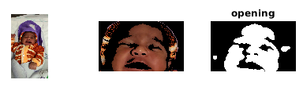 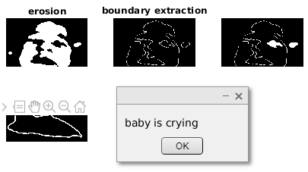

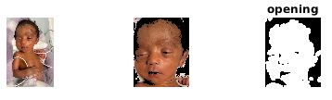

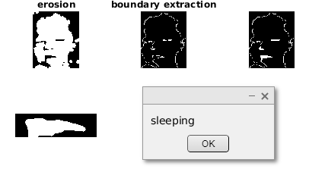

**Inference**

* Infant face images are extracted from recorded video from NICU and downloaded from online sources.
* The images taken in this study consists of preterm and full-term babies and facial features of babies are not well distinguished.
* **Features** considered from the above images- **Facial boundary and mouth region**.
* Further the algorithm is tested for different features like Both left and right eyes and eyebrows, nostrils opening, chin, tongues position for robustness of algorithm.
* Algorithm classifies images as happy, neutral, sleeping and crying categories.

**Method 2**

* Input video and convert into frames.
* Detect the infant face in the image and crop the region off the image,
* Resize cropped image. RGB to gray conversion.
* Convert the gray into binary image.
* Calculate area around eye and mouth (D)
* If (D<=-200)
* the facial expression is “Crying”
* Elseif (Se<=100 && Sm<=100 && D<=30 && D>=-70)
* the facial expression is “Sleeping”
* Elseif (D>=0)
* the facial expression is “Normal”
* End

**Output**

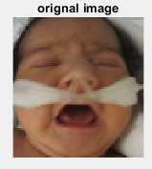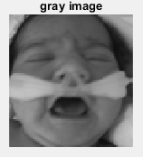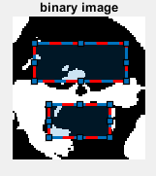

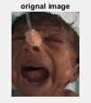 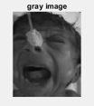 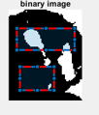

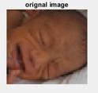 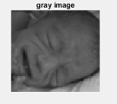 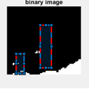

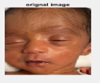 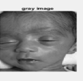 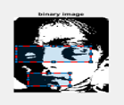

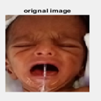 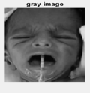 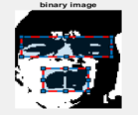

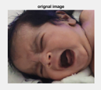 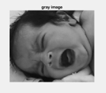 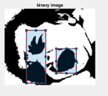

**Inference**

* **Features** considered from the above images- **Area around Left and right eyes and mouth region**.
* Further the algorithm is tested for features like left and right eyebrow position, nostril opening, chin curve for robustness of algorithm.
* Algorithm classifies images as neutral, sleeping and crying categories.

**Method 3**

**Emotion detection from infant facial expressions and cries**

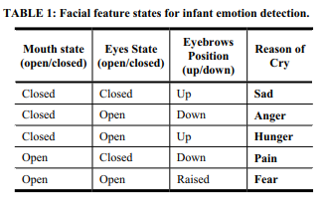

* The above paper uses infants images taken from internet sources and are hand labelled.
* The criteria to detect facial expressions are mentioned in the above table.
* The above criteria is checked for our dataset and it is found that most images fail to meet the above mentioned criteria.
* With the data available cry data ,classification is done into 3 classes namely hunger ,discomfort and pain.
* The scatter plot for the extraction features, namely pitch and entropy, is shown below for infant cries due to the pathological conditions hunger, discomfort and pain. The fine Gaussian kernel was found to provide
* a 79.0 % accurate classification of the given cries based on their reason for cry.
* Assuming the annotations of the cries from the chief nurse and experienced doctors from the neonatal department were accurate, the infant cries were further processed and classified. The Support Vector Machine classification used for the classification of these cries gave us an accuracy of 79%.

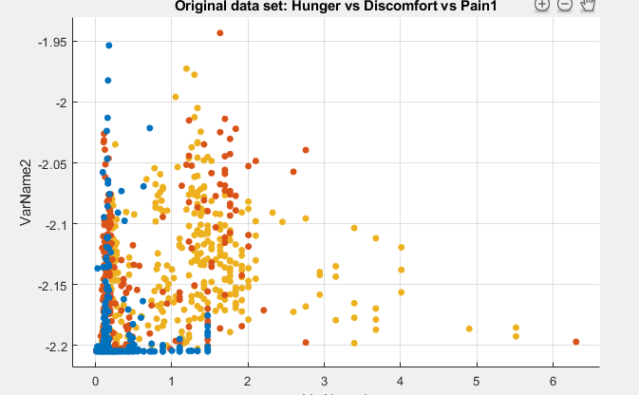

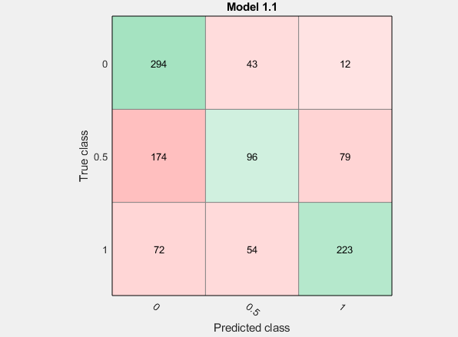

Figure 1 Confusion Matrix of SVM Classification for Hunger vs Discomfort vs Pain

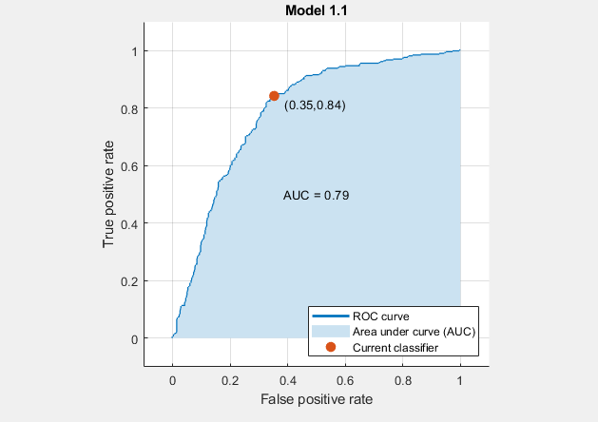

Figure 2 ROC Curve of SVM Classification for Hunger vs Discomfort vs Pain

**Classification results**

* Support vector machine (SVM) is used for classification.
* Video data collected from NICU at MSRH are annotated and labelled into three classes i.e., Moderate, None and Severe pain based on the Wong bakers pain scale.
* Moderate, none and severe are the three classes.



* Some of the key parameters in SVM are:

→Gamma: defines how far the influence of single training examples reaches values leads to biased results.

→ C: Controls the cost of miscalculations

Small C — makes the cost of misclassification LOW

Large C — makes the cost of misclassification HIGH

→ Kernel: SVM algorithms use a set of mathematical functions that are defined as the kernel.

* RBF (Radial Basis Function), Polynomial Kernel are deployed.



Below are results of classifier

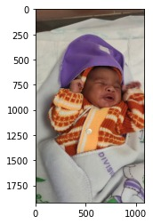

**moderate = 95.3253408163106%**

**None = 2.420899909551253%**

**severe = 2.2537592741381443%**

**The predicted image is: moderate**

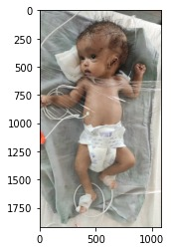

**moderate = 25.095100341583905%**

**None = 60.30653489330289%**

**severe = 14.598364765113189%**

**The predicted image is: None**

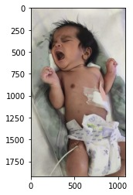

**moderate = 8.648209596205698%**

**None = 3.2216067411114846%**

**severe = 88.13018366268282%**

**The predicted image is: Severe**

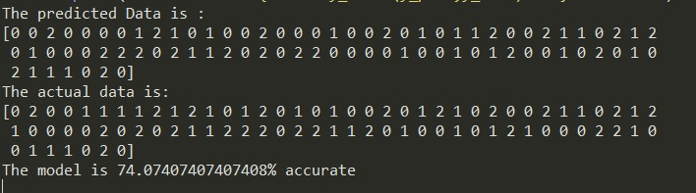

* Model is also tested for completely unknown data



**moderate = 40.38214589165237%**

**None = 20.109537893228474%**

**severe = 39.50831621511915%**

**The predicted image is: moderate**

**recall score for all three classes (0.7773809523809524, 0.7374162381175005, 0.7483076755104269)**

* Algorithm gives **74%** accuracy.

**Method 2**

**Classes**: Hunger, Discomfort and Pain for open source database.

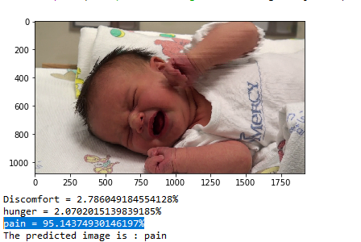

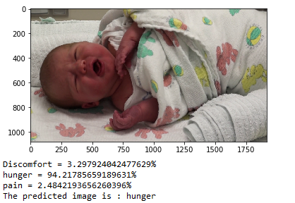

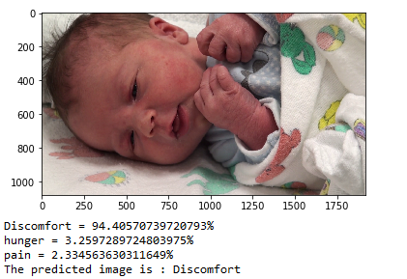

**Method 3**

**Classes:** Pain and no pain for open source database.

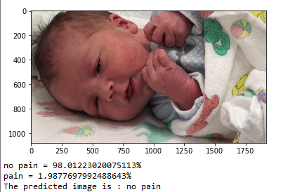

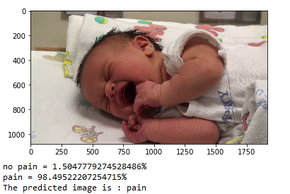

**HOG and Gabor features**

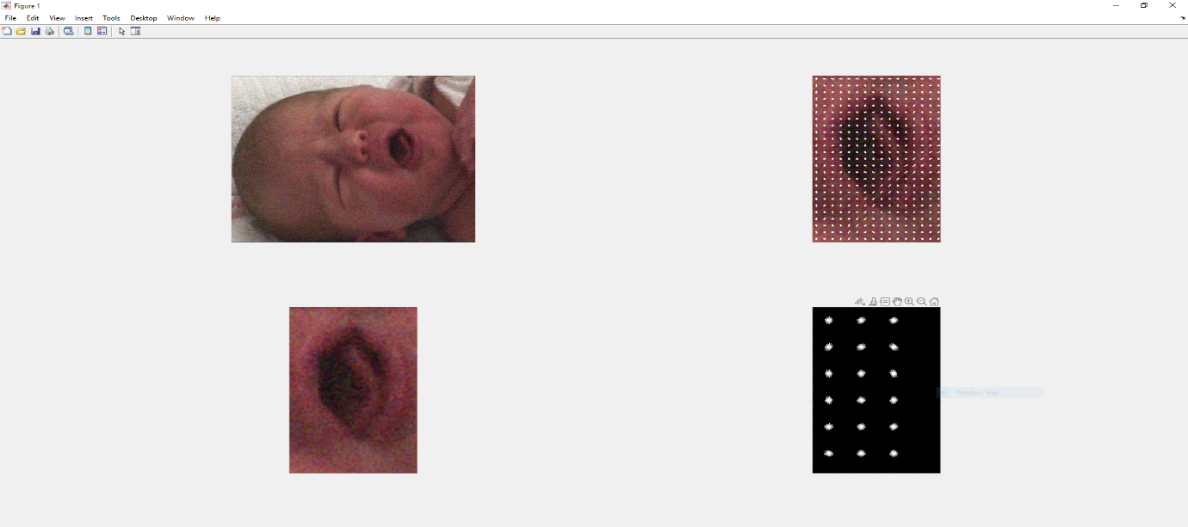

HOG feature for Moderate pain

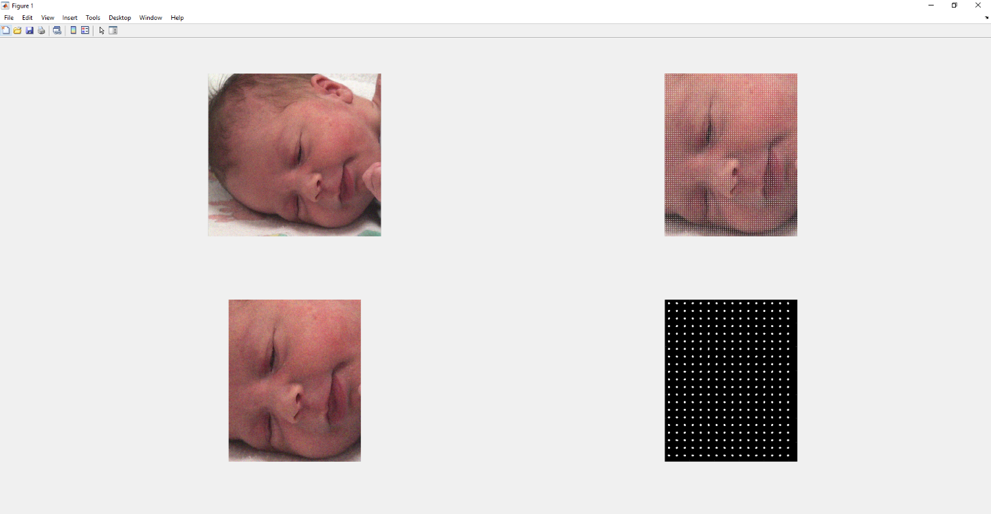

HOG feature for No pain

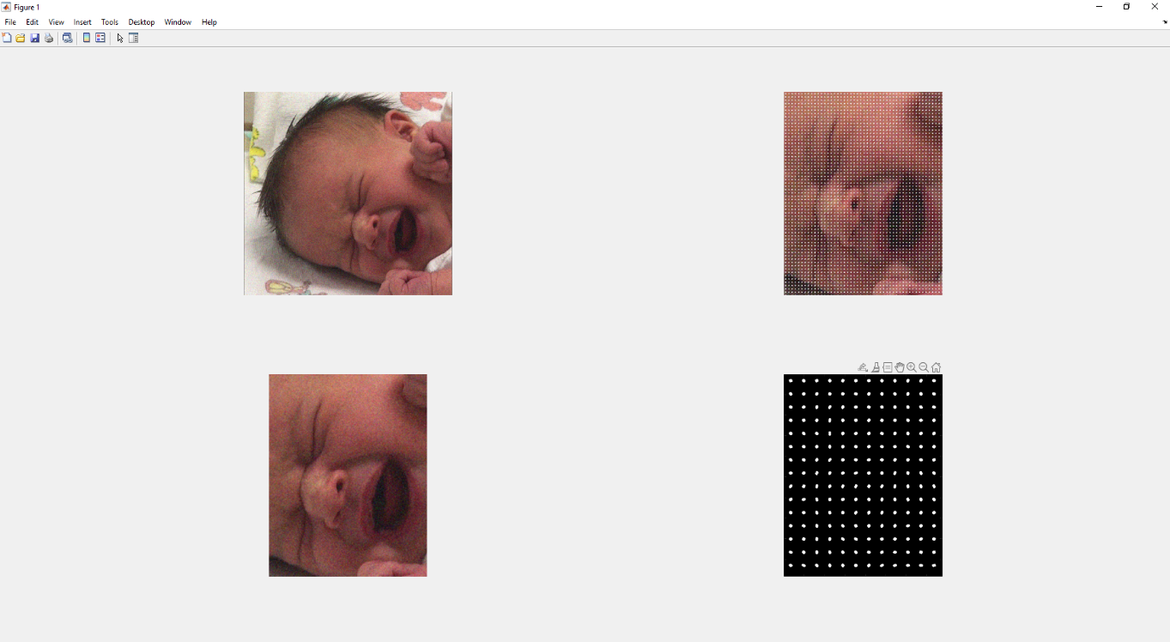

HOG feature for Severe pain

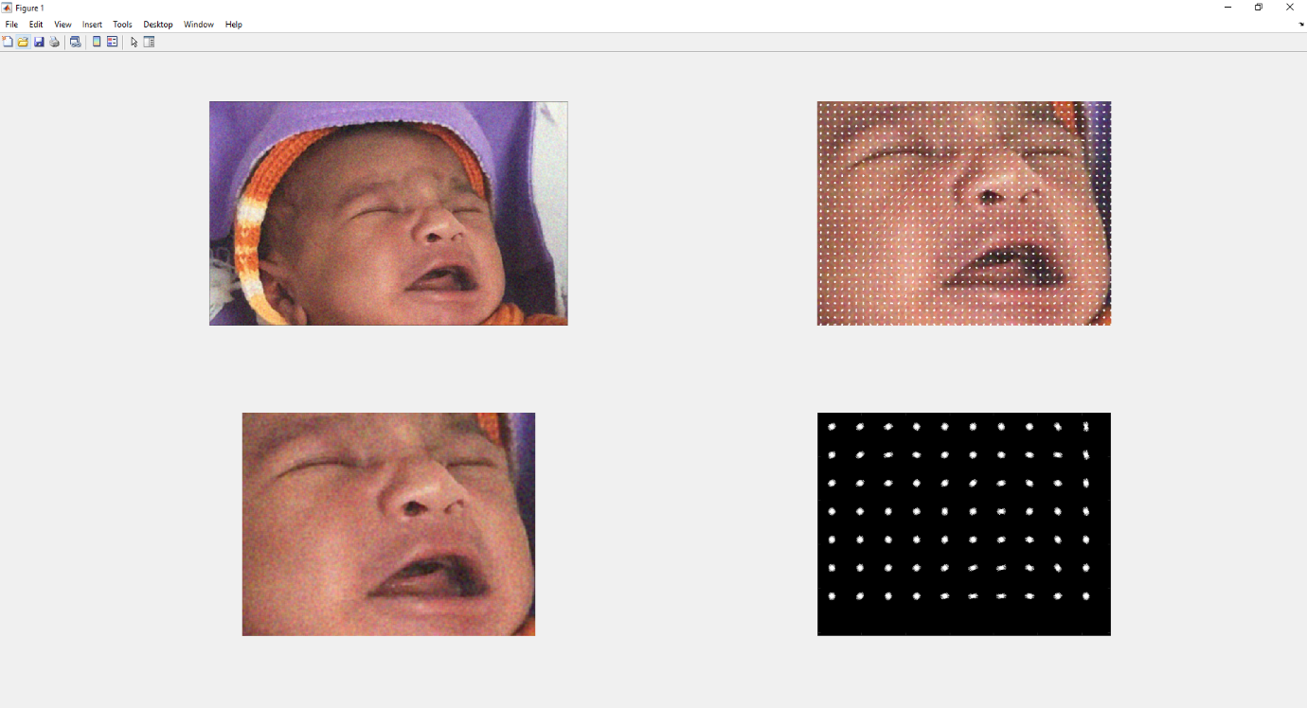

HOG feature for Moderate pain

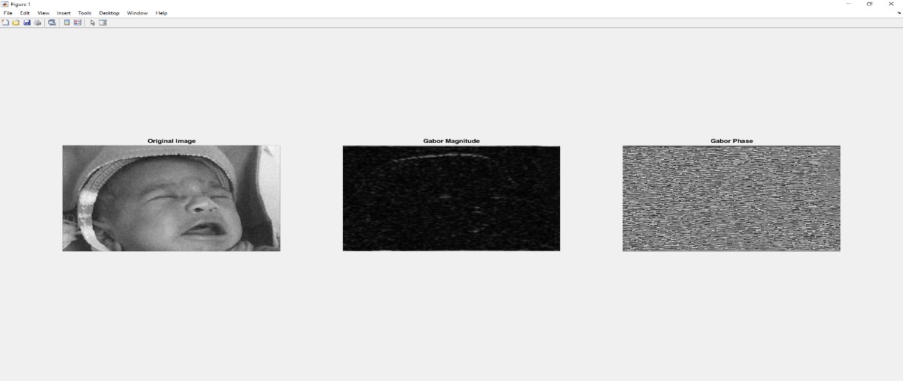

Gabor magnitude and phase for moderate pain

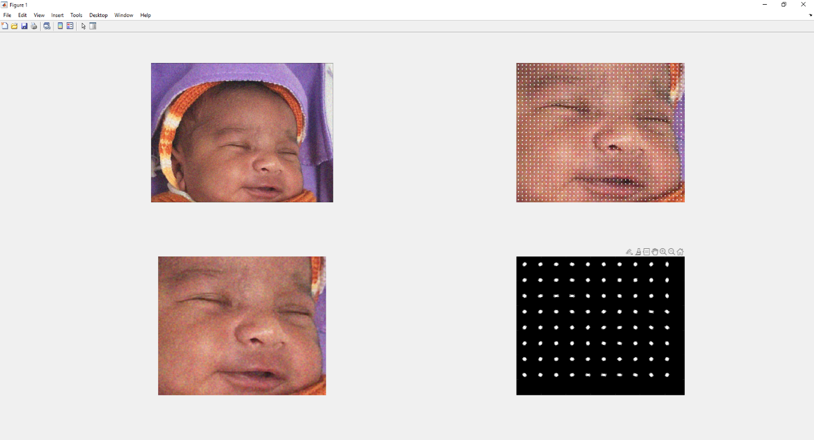

HOG feature for no pain

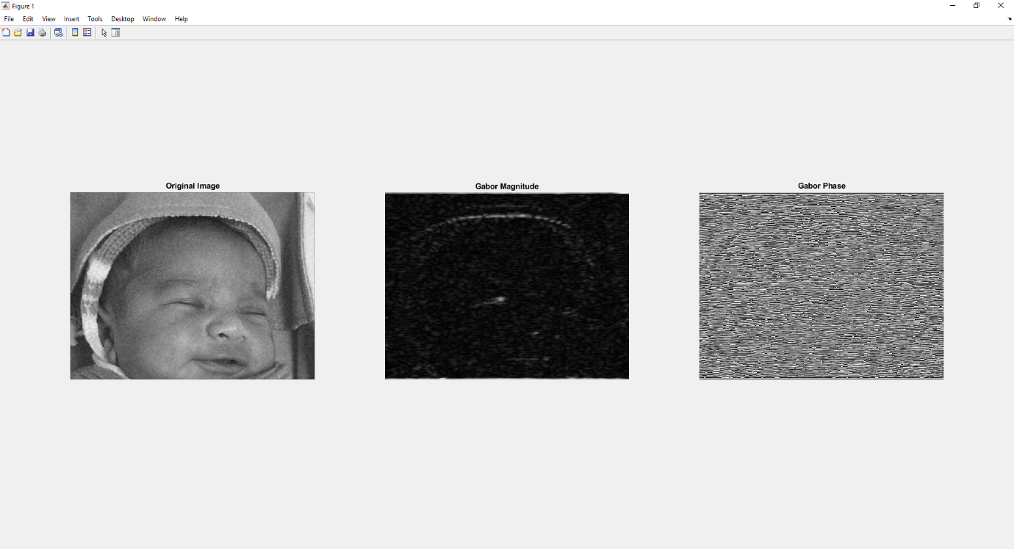

Gabor magnitude and phase for no pain

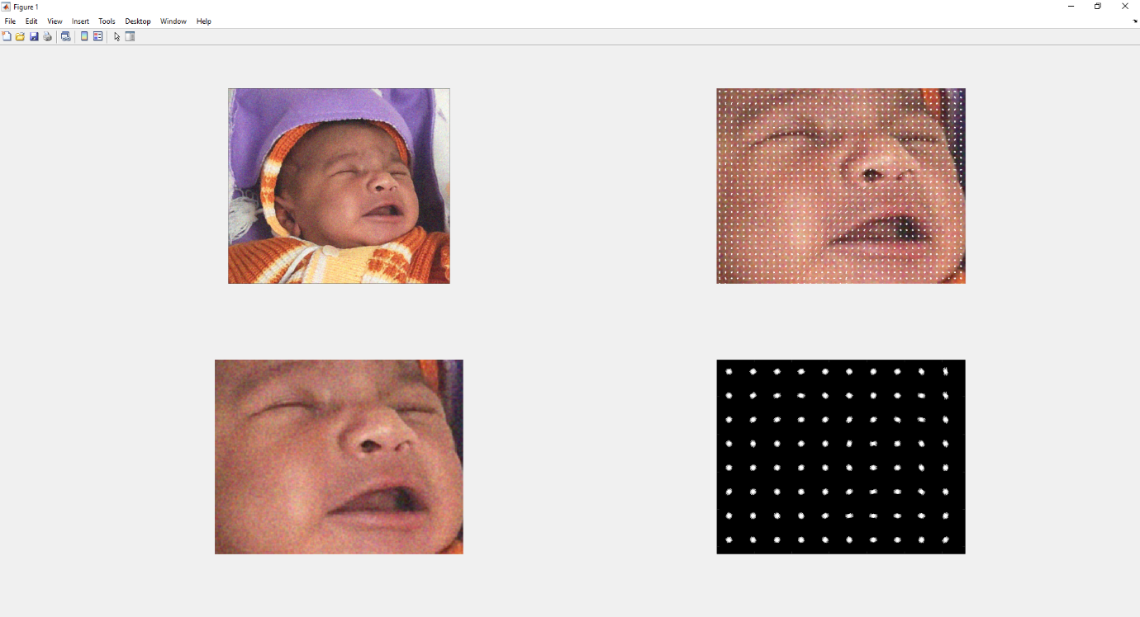

HOG feature for severe pain

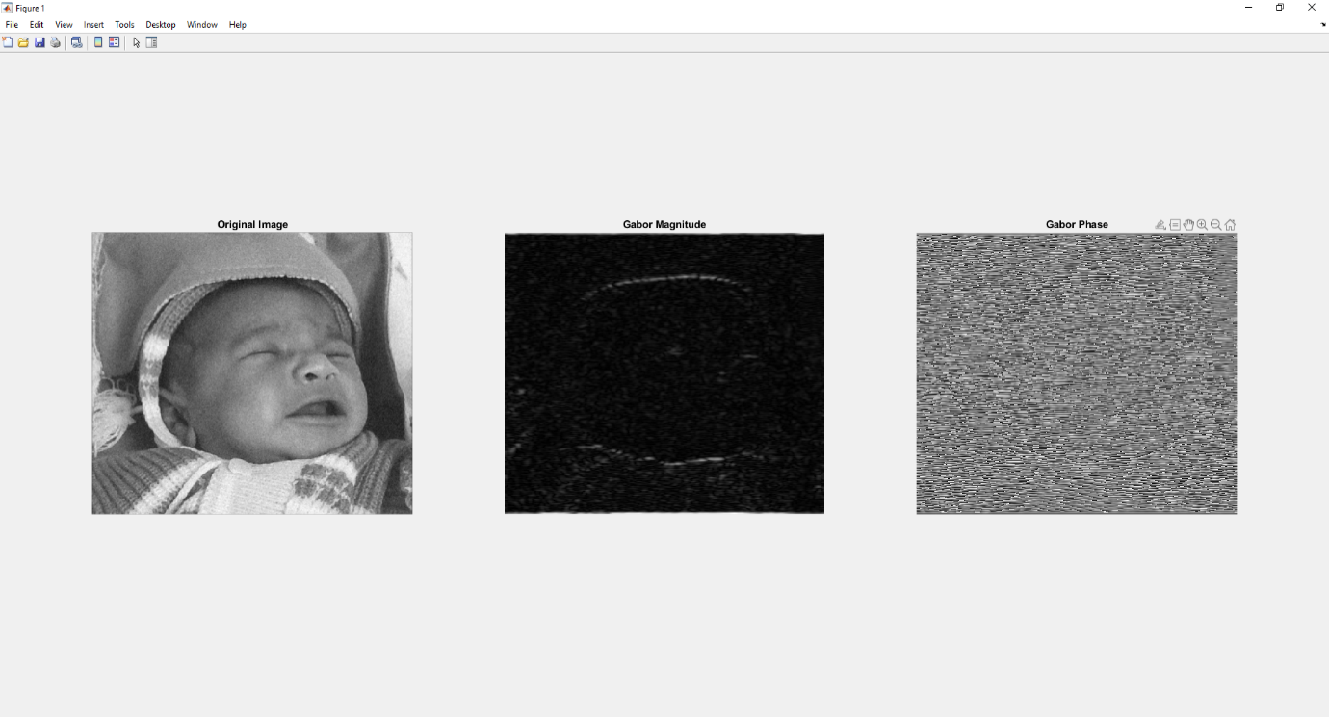

Gabor magnitude and phase for severe pain